Відділ освіти, молоді та спорту

Пирятинської міської ради

Пирятинский ліцей № 6

Пирятинської міської ради

Полтавської області

**НАВЧАЮЧИСЬ ВИХОВУЄМО**



**ІВЧЕНКО A.І., вчитель англійської мови**

Пирятин

2021

Івченко Алла Іванівна,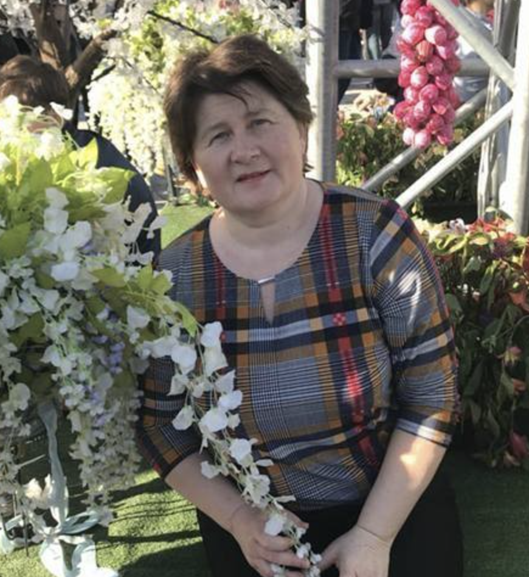

вчитель англійської мови

Пирятинського ліцею №6.

Вчитель-методист.

Педагогічний стаж - 31 рік

Навчаючись виховуємо. Посібник для вчителя. – Пирятин. Пирятинський ліцей №6 – 2021.–58с.

Матеріали посібника дозволять підвищити мотивацію до вивчення англійської мови. Пропонований посібник містить велику кількість тренувальних вправ.

Дана розробка рекомендована для використання на уроках англійської мови в загальноосвітніх навчальних закладах.

**Рецензенти**

Гавриленко Т.І. – заступник директора з навчально-виховної роботи Пирятинського ліцею № 6.

Алєксєєнко Т.В. – керівник педагогічної спільноти учителів іноземної мови.

Схвалено педагогічною радою Пирятинського ліцею №6 (протокол № 13 від 30.11. 2021).

**ЗМІСТ**

1. Вступ…………………………………………...…...4
2. Тема 1. Їжа. Улюблені страви………………......….5
3. Тема 2. Приготування їжі………………..…..…....12
4. Тема 3. Компоненти їжі……………….……….…18
5. Тема 4. Здорова їжа……………………...….…….25
6. Тема 5. Прийом гостей. Правила поведінки за столом. Мовний етикет……………………...........35
7. Тема 6. Традиційна українська кухня. Обід у

кафе, ресторані……..……………………….…….41

1. Тема 7. Американська їжа………….………….....47
2. Тема 8. Тематична атестація. Test on the topic "Meals".....................................................................54
3. Cписок використаних джерел………….……......58
4. Висновки…………………………………………..60

**ВСТУП**

Сучасні вимоги до викладання іноземних мов передбачають, перш за все, підвищення мотивації учнів до навчання, зокрема за рахунок максимального використання їхнього особистого життєвого досвіду та створення умов для самореалізації у процесі отримання знань, навичок і умінь. Це вимагає від учителя такої організації навчального процесу, за якої він є відтворенням реального життя, тобто учні вмотивовано виконують певні операції, типові або припустимі для їхньої повсякденної реальності, використовуючи при цьому іноземну мову як засіб спілкування.

Процес викладання іноземної мови неможливо уявити без використання таких видів навчальної діяльності, які б водночас з розвитком мовних і мовленевих компетенцій учнів забезпечували достатню мотивацію до вивчення іноземної мови як засобу спілкування.

На середньому етапі навчання такими мотивуючими видами діяльності, звичайно, є будь - які ігрові або змагальні моменти під час уроку. Учні навчаються під час гри або змагання, що дає їм можливість повністю реалізувати свій навчальний та особистісний потенціал. Сподіваюсь, що даний методичний посібник стане у пригоді вчителю під час вивчення і проведення уроків на тему «Харчування» у шостому класі.

**LESSON 1**

**ТЕМА. ЇЖА. УЛЮБЛЕНІ СТРАВИ**

**Practical***:* вдосконалювати навички аудіювання, розвивати діалогічне мовлення, вивчення нових лексичних одиниць, сприяти розвитку самостійного мислення.

**Developing**: сприяти розвитку мовної здогадки, вміння працювати з книгою.

**Educational**: навчати самостійно мислити, виховувати увагу, уміння чітко виконувати інструкції вчителя.

**Туре**: урок формування знань.

**Equipment**: підручник, тематична картина "Продукти харчування", карти для інтерв'ю "Opinion Poll".

**Хід уроку**

**І. Introduction**

Т: Good morning, everybody. I'm glad to see you. How are you? Sit down, please.

P: Today we'll start to learn the new theme "Food". That's why you'll have to remember healthy food, to ask and answer about your food preferences, about cooking your favorite dishes, about American food. Remember the proverbs:

* Live not to eat, but eat to live.
* Eat at pleasure, drink with measure.
* After dinner sit a while, after supper walks a mile.

**II. Vocabulary Presentation.**

**1. Семантизація нової лексики за допомогою наочності.**

Food: Dinner starters: soup, beetroot soup, salad, sandwich, broth (бульйон).

Main dishes: cutlet, sausage, porridge, potatoes(fried, boiled, mashed).

Dairy products: sour cream, curds, cheese.

Desert: pie.

Drinks: black coffee, juice, tea.

**2. Фонетичне відпрацювання введеної лексики.**

У структурах (group work).

І like/don't like...

I’d like to have... for dinner/lunch.

Do you want...?

Do you want to?

Do you want chicken?

Do you want first?

Do you want an omelet on a dish?

Do you want chips?

Do you want rice?

Do you want cutlets?

Do you want spaghetti?

Do you want beans?

Do you want pizza?

- I think they're nice.

**3. Match the pairs**

Salad сир

Cutlets рисова каша

|  |  |
| --- | --- |
| Sausage | суп |
| Soup | салат |
| Cheese | котлети |
| Rice porridge | бульйон |
| Broth | ковбаса |

**4. Тренування учнів у непідготовленому спілкуванні.**

Role-play. "To interview a neighbor and write down the daily menu".

|  |  |  |
| --- | --- | --- |
| Name | Food | Drink |
| For breakfast |  |  |
| Dinner |  |  |
| Lunch |  |  |
| Supper |  |  |

**5. Summarizing**

T: You have done a very helpful job. You managed to find out more about your classmates. It will help you to understand each other better.

|  |  |
| --- | --- |
| What do you have for breakfast? | |
| Food | Drinks |
| Porridge - 2 | Coffee - 2 |
| Salad-4 | Tea-1 |
| Sandwich - 8 | Juice - 2 |
| Fish - 2 | Milk-2 |
| Soup - 1 |  |

**6. Контроль навиків письма. Grammar**

(Вживання часів Indefinite, Continuous)

**Translate into English in writing.**

1. Хто любить готувати сніданок? - Моя мати.
2. Моя сестра не любить куховарити.
3. Я не люблю котлет.
4. Моя сестра звичайно не снідає о сьомій годині.
5. Візьми шматок хліба.
6. Зателефонуй мені через 15 хвилин, я зараз готую їжу.
7. Я вечеряв, коли увійшов мій друг.

**Reading**

Try to make these things in pairs. One of you will tell us about what you need and another will tell us about what you don't need. Use some and any.

Ex: borsch (малюнки капусти, моркви, сливи, картоплі, меду, буряка).

A: We need some cabbages, some carrots, some potatoes, some bubs.

B: We don't need any plums or any honey.

1. Vegetable soup (малюнки картоплі, суниці, гороху, солі, моркви, молока).
2. A lemon cake (малюнки риби, муки, масла, цукру, кефіру, буряку).
3. Varenuky (малюнки сиру, яєць, цукру, кефіру, винограду).
4. Strawberry jam (малюнки гороху, цукру, суниць, молоко).
5. A cup of tea (малюнки чайника з водою, вишень, пакетиків чаю, цукру, яєць).
6. A banana milkshake (малюнки помідорів, солі,бананів, морозива та вершків, молока).

**III. Заключна частина**

**Homework:**

1. Write down the new words into your vocabulary and learn them.
2. Write down your daily menu.

**LESSON 2**

**ТЕМА. ПРИГОТУВАННЯ ЇЖІ**

**Practical:** практикувати учнів у правильній фонетичній вимові нових лексичних одиниць; розвивати навички діалогічного мовлення з теми.

**Developing:** розвивати навички діалогічного мовлення учнів, вчити учнів творчо виконувати завдання.

**Training:** виховувати здорове прагнення до їжі.

**Educational**: навчати учнів здобувати, аналізувати і використовувати інформацію.

**Equipment:** тематичні малюнки "Види їжі"; підручник; текст для аудіювання "A hot dog"

**Хід уроку**

**І. Introduction**

Good morning, children!

**Warning up**

When do you usually have breakfast (dinner, supper)?

What do you (your mother, father, sister) have (has) for breakfast?

How long does it take to fix breakfast (supper, dinner)?

II. **Introducing the topic.**

You are alone at home and you must prepare dinner for your parents. (For this, the pupils will need to know the verbs that describe the process. The words should be introduced by means of pictures illustrating the activity:

Wash - мити

Peel очищати шкурку

Cut ['kAt] різати

Slice [slais] ділити

Chop рубати, кришити ножем

Dice різати кубиками

Grate терти на тертушці

Boil [boil] кипіти, варити

Fry [frai] жарити

Roast [roust] смажений

Bake [beik] пекти

Stew [stju:]тушити

Serve подавати

Grill [gril] гриль

Steam [stirm] випаровувати

The pupils should pick the dish they will help tо cook, find out the ingredients and work out a joint decision.

**1.Основна частина уроку.**

Активізація лексики з теми "Їжа"

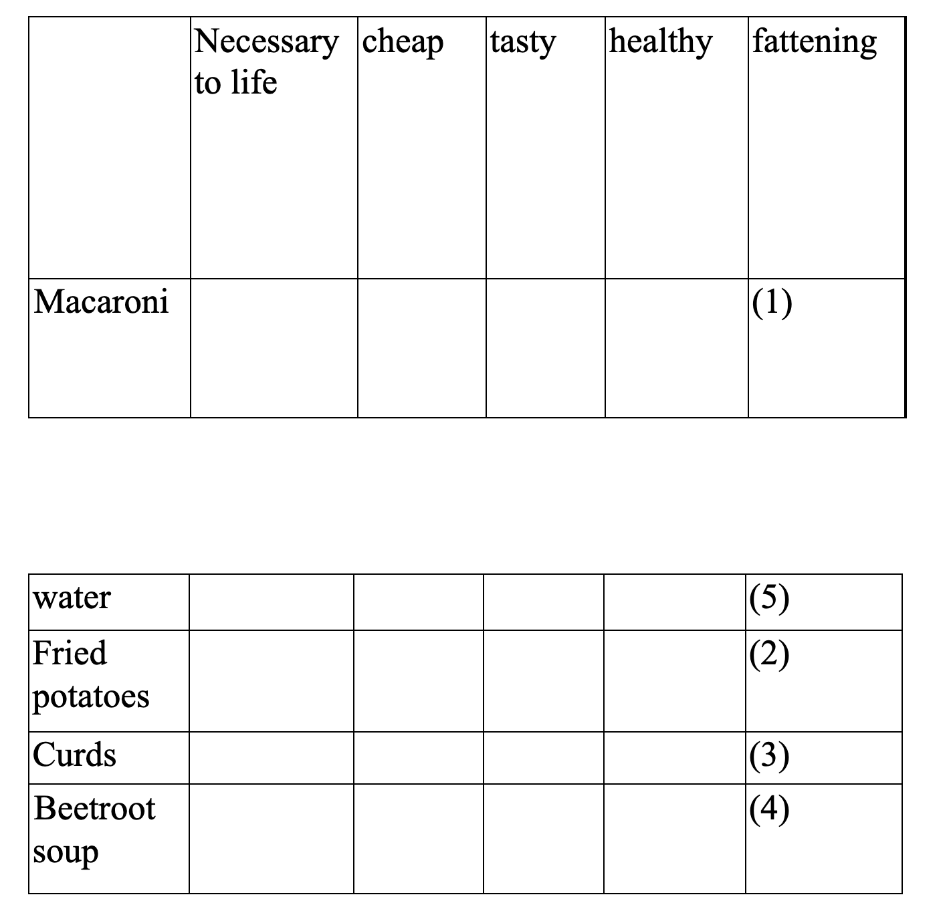

T. Rank the dishes according to the five qualities. For example if you think that you can get fat because of eating too much macaroni, put 1. Tried potatoes may be the second reason for getting fat, and so on.

**2. Практикування учнів у спілкуванні.**

Say what we can do with these foods. Use the verbs from the first column and the nouns from the second column.

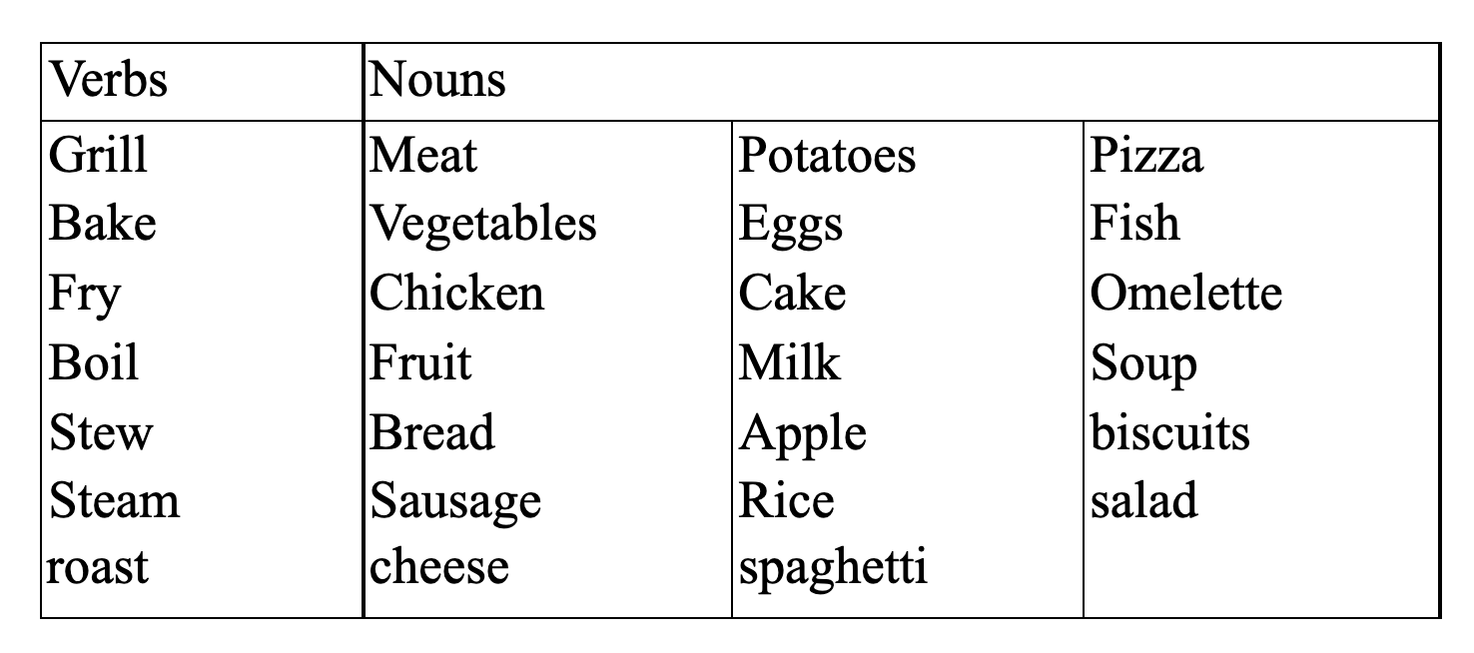

**3. Представлення тексту для читання.**

Pre - reading activity. Етап підготовки до читання тексту.

Т.: What do you know about a hot dog?

Is it testy?

You all know that the hot dog is one of the most popular food in the world. It looks very simple -just a sausage put between the two parts of a long bun. It is a very tasty and fast snack. It first appeared in Germany where sausages are national food. People wanted to be able to have a sausage on a piece of bread, and so the hot dogs came to life. At first, they were not called "hotdogs". They had a German name after a dog **with** a very long body and very short legs. An American once drew a cartoon about these sausages for a newspaper.

He did not know how to spell the German word , so he called that sausage "a hot dog". The name has become very popular, and we have known this tasty food as "hot dogs" since then.

**Завдання. I agree or disagree.**

1. Hot dog appeared in America.
2. Hot dog is not popular food in the world.
3. Hot dog is a sausage put between the two parts of white bread.
4. Sausages are national food in France.
5. A sausage between the two parts of long buns is called a "hot dog".

Key: 1-; 2*-; 3-; 4-; 5+.

**2. Retell the text**

**т-P1, P2,Р3;**

**3. Фізкультхвилинка:**

T: "Let’s have a rest; sing a song "The More we are". Together"

The more we are together,

Together, together.

The more we are together,

The happier we'll be.

For your friends

Are my friends

And my friends

Are your friends.

The more we are together, together, together.

The more we are together,

**4. Писемне мовлення**

Make a **list of your five most favorite** dishes **and** five things **you** hate **to** eat.

**Заключна частина уроку. Домашнє завдання.**

1. Practice orally in translating all-new word - combinations.
2. Read the jokes, translate and retell them.

**LESSON 3**

**ТЕМА. КОМПОНЕНТИ** **ЇЖІ**

**Practical:** вчити учнів свідомого ставлення до вживання їжі;

удосконалювати навички говоріння через інтерактивні види діяльності.

**Educational:** розвивати навички письма, вчити логічно та послідовно висловлювати свої думки.

**Developing:** розвивати вміння застосовувати знання на практиці; логічно та послідовно висловлювати свої думки, вчити творчо виконувати завдання.

**Обладнання:** підручник; тематичні картки на тему " Food'"; тематична картина на тему: "Cooking"; римування " The Hot Dog Song"; рецепт піци.

**Туре:** урок закріплення і вдосконалення знань.

**Хід уроку**

**1.Повідомлення теми та мети уроку.**

The topic of today's lesson is «Food ingredients". By the end of the lesson, you should be able to talkabout how to cook dinner; how to cook your favorite dish using the topic words. Also, I'd like to get acquainted with the origin of the most popular dishes.

But the best will be to begin by listening to the jokes or funny stories about cooking, cooks and meals that you were to prepare for the lesson.

**II. Уведення в іншомовну атмосферу.**

1. Telling jokes. Перекази смішних оповідань про їжу.
2. If the class listens to you attentively and laughing expresses their understanding so it was excellent.
3. Pronunciation drill. Jazz - chant Читання віршу.

T: Now, to make your speech more fluent and to make you sound natural, let's learn another jazz - chant.

The Hot Dog Song

Have you ever had a hot dog with mustard and mayonnaise?

Have you ever had a hot dog with pepper and salt?

With mustard and mayonnaise and ketchup and pickles.

Have you ever had a hot dog with pepper and salt?

With mustard and mayonnaise

And lettuce and onions

And mustard and mayonnaise

And mustard and pickles

And lettuce and onions

And mustard and mayonnaise

And pepper and salt

**II. Основна частина уроку.**

**1. Активізація лексики теми " Food".**

Speaking about healthy food.

Т.: Form groups A,B,C,D and discuss your opinions about dishes. Speak about your favorite dish and analyze its qualities. By the way, what food is considered to be healthy? Possible answers:

* It must have vitamins;
* Minerals for my blood;
* Proteins to help you grow;
* Fats, but not many, to feed your muscles;
* Carbohydrates give you energy.

**3. Робота над текстом "I Prepare My Dinner"**

1. Pre - reading activity . Етап підготовки до читання тексту.
2. Presentation of the recipe for the favourite dish. Introduction of problem vocabulary.

**Семантизація лексики, необхідної для описання способів приготування їжі за допомогою:**

**Наочності Показу** дій

То lay the table to cook

То serve to fry

То clear the table to stew

A table - cloth to boil

A knife, a spoon, a fork, a tablespoon to add

A napkin to mix

A salt – cellar to pour

Переклади

To grate - терти

To chop - рубати

To mince - подібнювати у м'ясорубці

To skin - очищати від шкіри

То peel - знімати шкурку

То oil - змащувати олією

То cut - різати

Т.: This is my favourite dish recipe

**1. Conversation about cooking**

What traditional dishes do you usually cook in your family when you invite someone for a holiday dinner (birthday) New Year's Day, Christmas, etc? Can you explain what they are made of? Now, do you cook them? Example

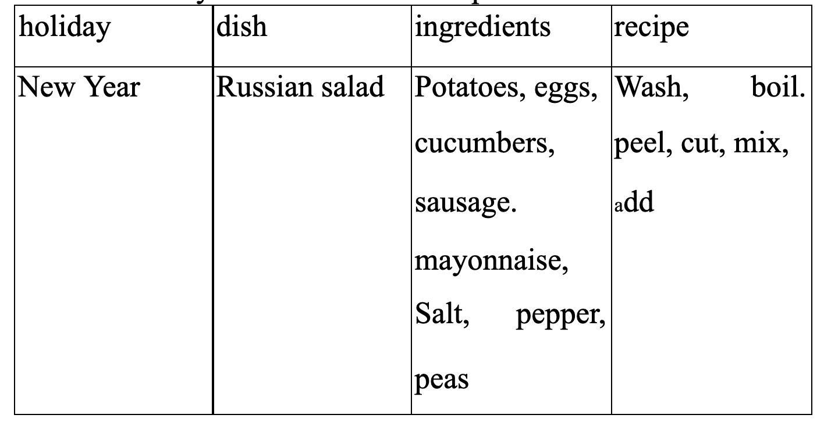

2. **Виконання письмової тренувальної вправи.**

Read the recipe. Fill in the gaps with the words from the box.  
Guess what recipe it is.

Add, boil, cut, get, mash, peel, put, take, wash, add

...(1) 3or 4 potatoes... . (2) them. Then ...(3) them carefully. If the Potatoes are very big, ...(4) them into smaller pieces. Then ... (5) them into cold water, ... (6) some salt and ... (7) till they are ready. ... (8) the water out and ... (9) some milk and butter. ... wait till the milk starts boiling. ... (10) everything carefully.

**3. Read the text and match the words in bold type with their Ukrainian equivalent.**

Білки, вітаміни, вуглеводи, жири, клітковина, мінерали

Your body needs six things to grow and be healthy: carbohydrates, fats, fibre, minerals, proteins and vitamins. Carbohydrates give you energy. Fats give you energy and help to keep you warm. Fibre is very important for your body to work well. Your body also needs about twenty different minerals. Proteins help your body grow. Vitamins help to keep you healthy. It is important that your food has all of these things. But it is also important that you don't eat too much or too little. This is what Ron likes to eat on Sundays. What useful things has he got in his food? Is this food healthy?

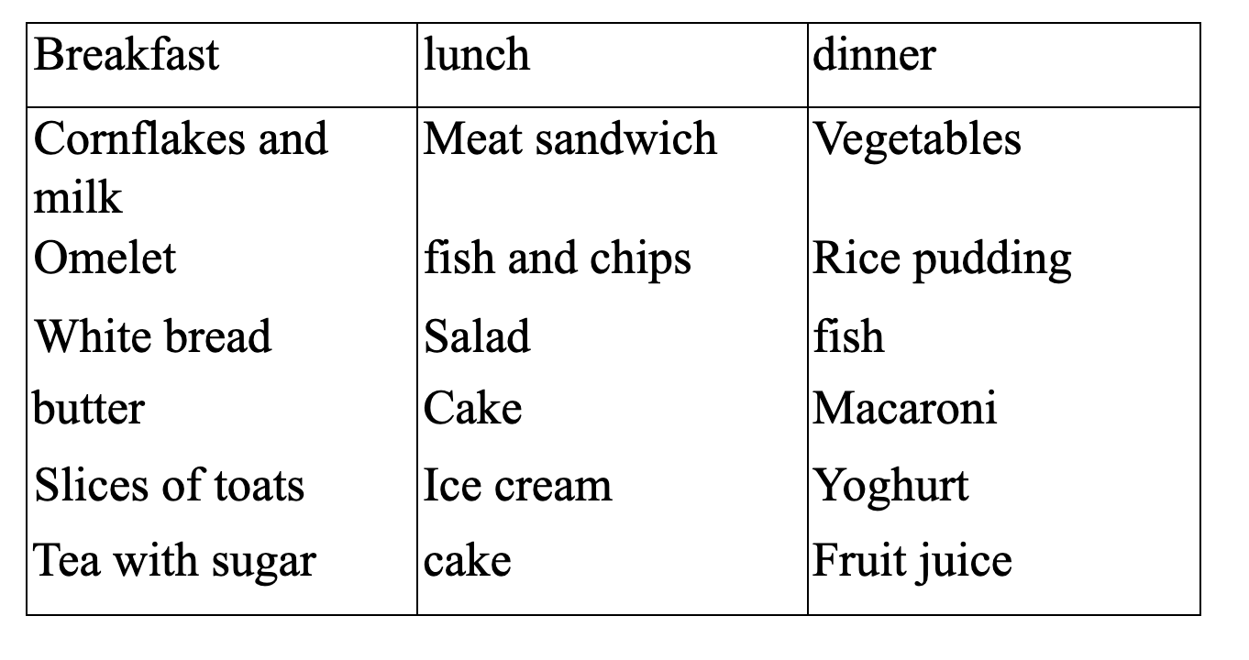

1. **Write down everything you eat during one day.**

**Put down the time and the food.**

**III.** **Заключна частина**.

Домашнє завдання.Write down everything your friend usually eats during the day ... Put down the time and the food.

**LESSON 4**

**ТЕМА. ЗДОРОВА ЇЖА**

**Practical** : систематизувати вивчену лексику в мовленні.

Educational: розвивати вміння будувати діалоги по темі уроку та вміння ставити різні види запитань.

Developing: розширити знання учнів про здорову їжу; пригадати правила етикету за столом; спонукати дітей до свідомого ставлення до свого здоров'я.

**Обладнання:** малюнки з овочами та фруктами, малюнок світлофору, малюнки із завданнями, музичний супровід, прислів'я.

**Хід уроку**

1. **Introduction.**

Today we are having a summary lesson about healthy food because health plays an important part in the life of all people. Now we shall have a lesson in the form of a game. Beforehand all pupils were divided into two groups : fruit and vegetables.

We have the motto of our lesson, but we must guess it. On the blackboard you can see unscramble sentences. Put them in the right order and you will read it. Motto: "A sound mind in a sound body".

All of you want to be healthy. One of the main things of health is to eat properly.

1. **The main part.**

1. Т.: As you know every topic can be presented through proverbs.

Read the proverbs and translate them.

An apple a day keeps the doctor away.

Appetite comes with eating.

Hunger is the best sauce.

Т.: What is your attitude to food?

P1 |.: As for me, different kinds of food help our body to keep fit and to be strong and healthy. That's why the food must contain all the things we need.

P2. : To my mind, we must eat everything we want, but not too much of any one thing.

**3. The Traffic - Light Diet.**

**Т.:** We can classify different kinds of food into three groups. It will look like a traffic - light diet.

**Т.:** By the way. how many colors has traffic - light? According to its colors we shall group food.

Green ( means go right ahead) and we must eat the following foods as: Fruit, salad, vegetables, cheese, bread, tea (without sugar) and water.

Red (stop and think) .These foods have a lot of fat or sugar or salt: sweets, chips, butter, ice-cream, jam.

Yellow (go carefully) and eat carefully: eggs, meat, pies, pizza.

Name a "red" food that has too much salt.

Why is ice- cream a "red" food?

Name a "green" food that you like.

**Т.:** In fact, some people deny themselves nothing. They enjoy different tasty foods. Others try to keep to a diet.

**4.** (на дошці представлені різні овочі та фрукти. На кожному з них завдання)

**Т.:** What fruit or vegetable do you like?

**P.:** I like apples.

**Т.:** Now we shall see what task has this fruit or vegetable.

Tasks:

Sing a song;

Recite a poem ;

Guess the riddle;

Name bitter vegetables;

Say what cows like to eat;

Name 4 things that have milk in them;

Name the traditional food of Ukraine.

Т.: Do you like to see "Eyelash". Look and listen what food they like to eat and how he sits at the table.

1. **Scene: "Dinner Time."**

( Відбувається сцена між сином та мамою. Син повернувся стомлений додому, голодний)

Son: I'm hungry. I want some cakes.

M.: There isn't any. Would you like a fried potato?

S.: No. Are there any sweets?

M.: No, there not. Would you like vegetable- salad?

S: No. I'd like chips.

M.: It's a pity, but we have not chips. We have apples.

S: No. thanks. I'm not hungry now.

Т.: What food does he like?

How does he sit at the table? What can you advice him?

Advices

Wash your hands with soap before breakfast, dinner and supper. Don't talk when you eat.

Don't put your knife in your mouth.

Don't make faces when you see a meal that you don't like.

Don't put elbow on the table.

Don't eat fast.

Hold your fork in the left hand and your knife in the right hand when you eat.

Say "please" when you ask people to pass you something.

Say 'Thank you" after each meal.

Т.: What do you like for breakfast? What do you like for dinner?

What do you like for supper?

1. **Finish the sentence.**

To stay —> healthy —> people and must —*>* eat —> fruit

vegetables.

**7. Relaxation.**

Т.: As you see, all of you have emblems. Introduce yourself.

P.: I'm apple. I'm red and sweet. 1 grow on the apple - tree in our

kitchen garden. All children like me.

**Training exercises:**

(Учням дається картка, на якій написане слово. Учні повинні пояснити значення цього слова, не називаючи його)

Raspberry —► It is very red and sweet.

**8. Read the words in alphabetical order.**

Tea, water, milk, coffee, cocoa, compote, bread, meat, sugar, borsch.

Cheese, butter, fish, sausage, cutlet, porridge, salad, soup, ice- cream, sweets.

**9. Fill in the missing letters.**

The line of letters below is a sentence in which even letter E has been left out. You must put this letter in 5 times, and also find where to leave spaces between the words.

**IATBRADANDCHS.**

Key: I eat bread and cheese.

**1. Listen to the text:** "A polite question".

Peter was ten years old. One day his friend Paul said to him." I'm going to have a birthday party on Saturday, Peter. Can you come?"

Peter asked his mother, and she said," Yes, you can go". She phoned Paul's mother to tell her.

Before Peter went to the party on Saturday afternoon, his mother said to him," Now, Peter, don't forget to be polite. Don't ask for food.

Wait until someone gives it to you".

"All right. Mum," Peter answered, and he went to Paul's house on his bicycle.

There were a lot of children at the party. They played together for an hour, and then Paul's mother gave them some food; but she forgot to give Peter any. He waited politely for a few minutes, and then he held his plate up and said loudly. "Does anyone want a nice clean plate?"

Say if the statements are true or false. There you can see letters; with the help of these letters make up a sentence

1. Peter was ten years old.
2. Paul is going to have a birthday party on Sunday.
3. Peter went to the party on Saturday afternoon.
4. Peter's mother said: "Don't forget to be polite."
5. Ask for food.
6. Peter went to Paul on foot.
7. There were many children.
8. They played for two hours.
9. Paul's mother did not give Peter any food.
10. He waited for a few minutes.
11. He sat still.
12. He asked: "Does anyone want a nice clean plate?" Key: ( We are winners)

**2. Make the sentence true to the text.**

1 . Peter was —

1. ten
2. eleven
3. nine
4. twelve
5. His friend's name was —
6. Paul
7. Peter
8. Patrick
9. Pam
10. Peter went to Paul's house by —
11. Car
12. plane
13. Bus
14. bicycle
15. Peter asked if anyone wanted **a** nice clean
16. Shirt
17. plate
18. cup
19. cap

**3. Заключна частина**

Taking into account your activity during the lesson your marks are

The team "..." won. My congratulations to you.

And now let's do an exercise: "Before saying "Goodbye"

Nod you head,

Bend your knees

Grow as tall

As New Year trees.

On your knees

Slowly fall

Curl yourself

Into a ball.

Raise your head,

Jump up high,

Wave your hand

And say "Good-bye".

**A Song "Yummy, Yummy".**

I Like chocolates,

Yummy. Yummy

I like chocolates, I like cakes.

Cakes and chocolates.

Yummy. Yummy.

I like ice cream.

Yummy. Yummy.

I like ice cream, I like sweets

sweets and ice cream.

Yummy. Yummy.

I like ice cream, I like sweets

Yummy. Yummy.

**Poems**

1. What do you like for breakfast, Lee?

like two eggs, some milk and tea.

What do you like for lunch, Kate?

I like a plate of soup, some fish and cake. What do you like for dinner, Pete? I like potatoes, soup and meat. What do you like for supper, Sam? I like some cheese, some bread and ham.

1. We often go shopping, me and Ted. We often buy sugar, butter and bread. We often buy sausage, ham and cheese. We often buy carrots, cabbage and pears.

**Riddles**

1. Clean, but not water  
   White, but not snow  
   Sweet, but not honey.  
   What is it? (milk)  
   Riddles
2. It is red and sweet, it is good to eat. (an apple)

**LESSON 5**

**ТЕМА. ПРИЙОМ ГОСТЕЙ. ПРАВИЛА ПОВЕДІНКИ ЗА СТОЛОМ. МОВНИЙ ЕТИКЕТ**

**Training:** ознайомити учнів з правилами прийому гостей та правилами поведінки за столом.

**Practical:** розширитита повторити словниковий запас учнів за темою; удосконалити навички читання та говоріння учнів через інтерактивні види діяльності. 

**Developing**: розвивати вміння інсценізування діалогу; розвивати мовну здогадку та мовленнєву реакцію учнів.

**Educational**: виховувати повагу до культури інших країн, формувати міжкультурну компетенцію.

**Equipment**: тематичні малюнки на тему римування НО і; НО2; НОз)

**Туре**: урок формування умінь і навичок.

**Хід уроку**

**І. Introduction**

Т.: The topic of today's lesson is Receiving guests and Having lunch or dinner in a family or in cafe. By the end of the lesson you should be able to invite guests for dinner, to talk and to behave appropriately at the dinner table and to have table manners.

1) Brainstorming.

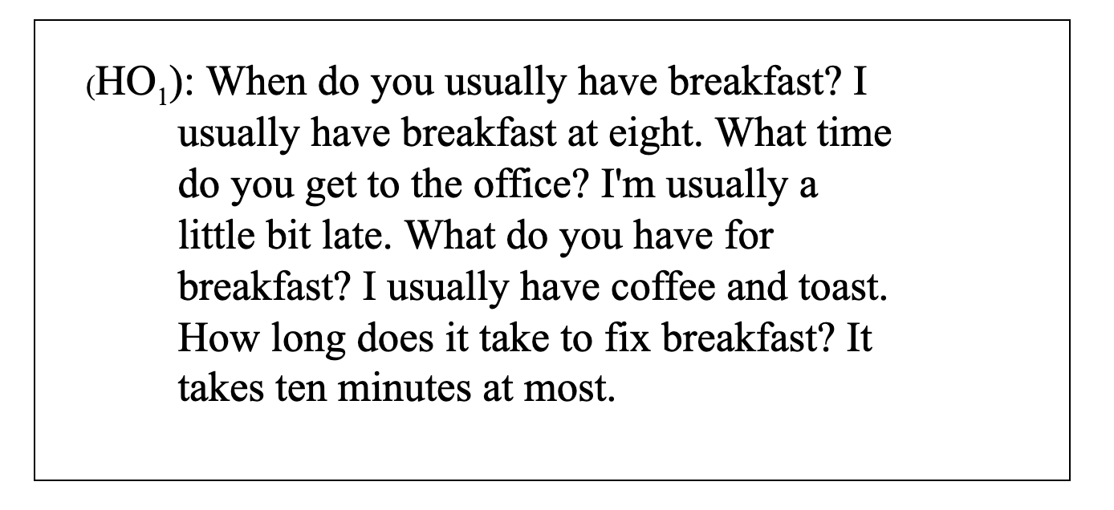

What do people usually have for meals in your family?

**II. Основна частина уроку**

**1. Контроль домашнього завдання.**

Arrange the pupils round the table.

Simulation: you are having dinner and talking about daily meals.

PI: Do you like to (cook) prepare meals?

P2: Yes, I like to cook (prepare) meals.

P3: Does your sister like to cook?

P4: No. she doesn't like to cook.

**2. Тренування учнів непідготовленому висловлюванні за темою.**

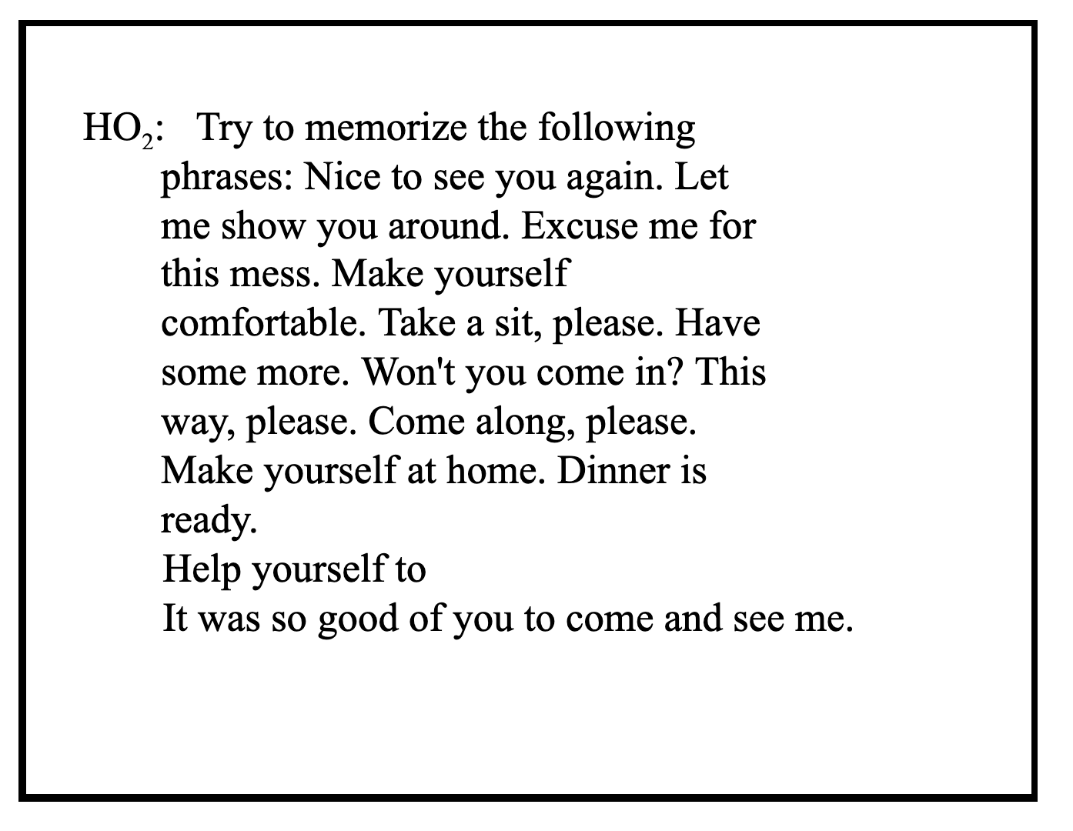

**3. Read and translate**

« The ABC of Table Manners». «Do «or» «Don't» statements are mixed. Divide them into two groups.

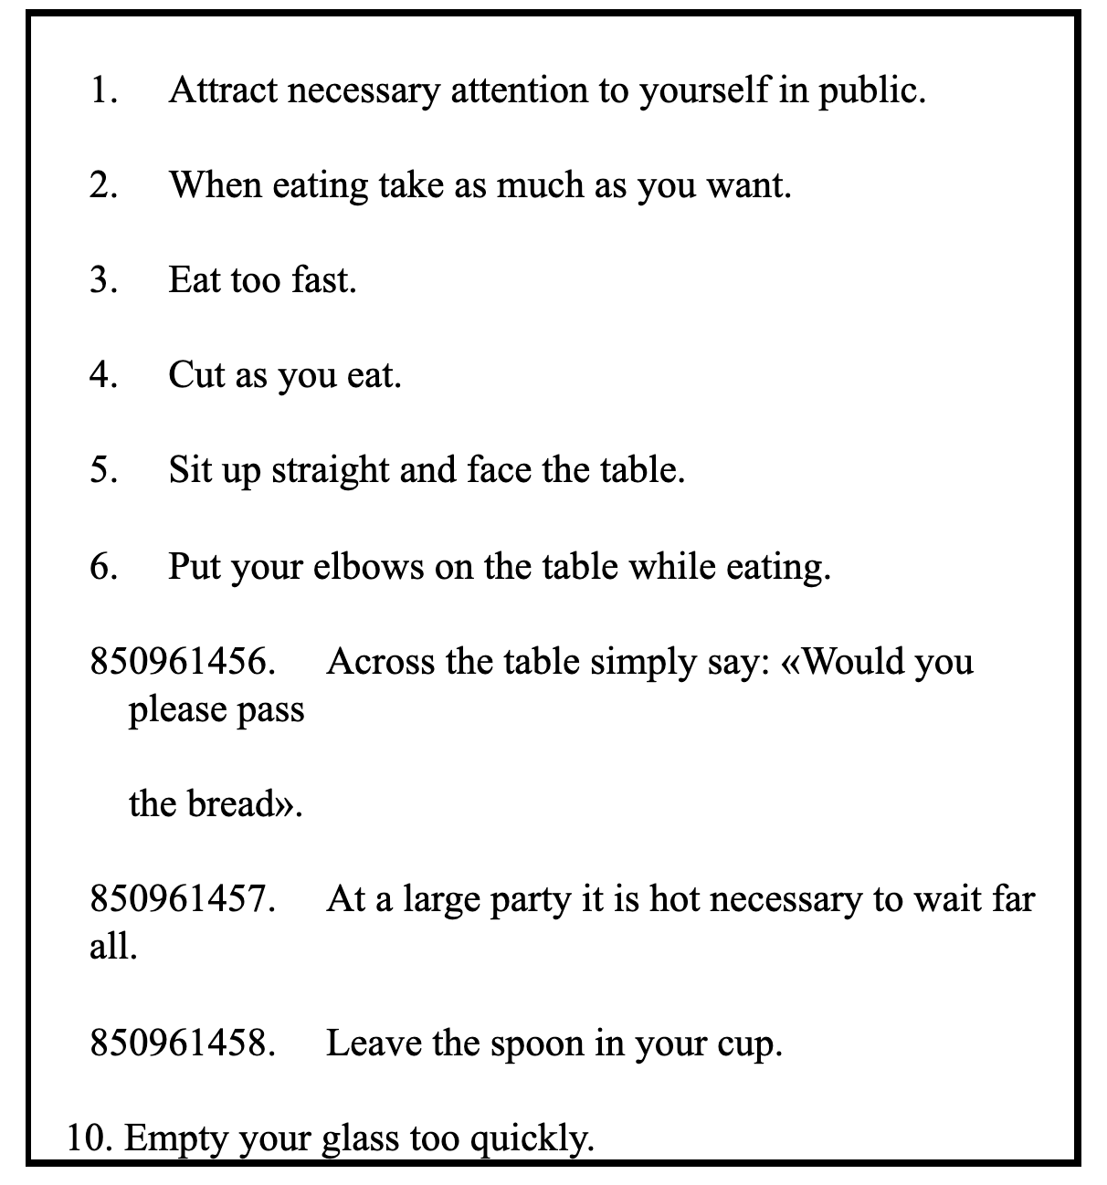



Put the words and word combinations from the box into the table

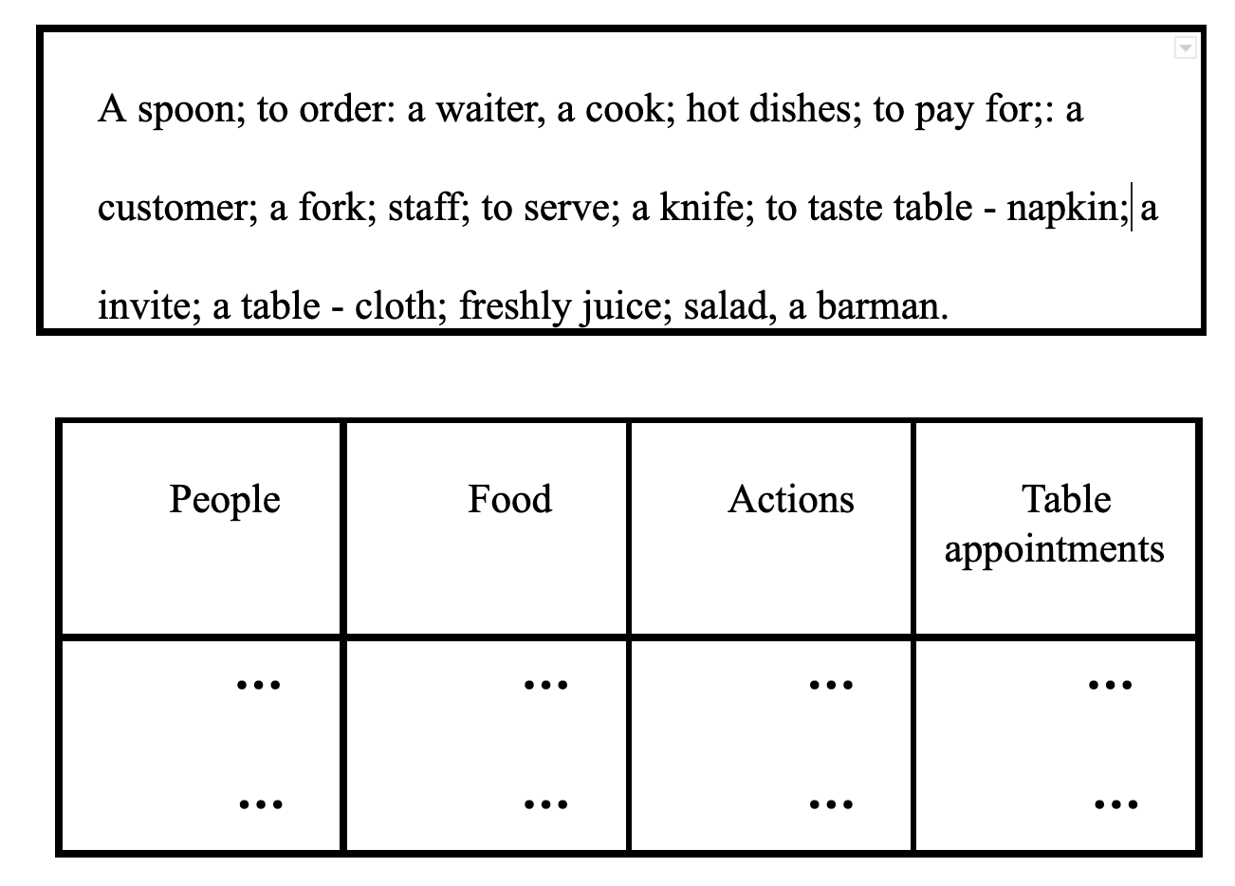

**4.Put the words below into two appropriate groups.**

Carrot juice, hamburgers, cabbage, beer, cereal, grapes, crisps, sweets, yoghurt, beef; peanuts, watermelon; chocolate, fruit salad; coffee, soup, cake, fish, cheeps, strawberry, cheese, potato.

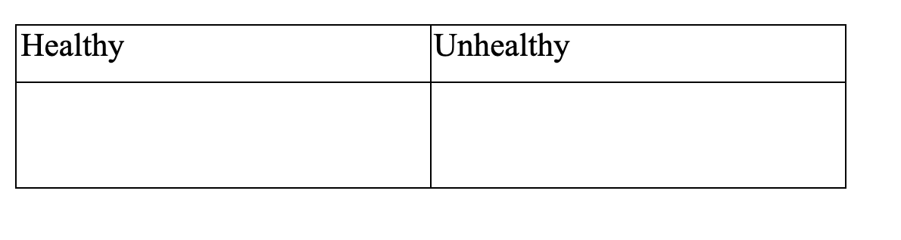

**III. Заключна частина уроку.**

**Homework**

Т.: At the next lesson we'll speak about our visit to cafe and about Ukrainian food. Please, recall and note down what else you usually say to waiter (waitress), what traditional dishes you have at your parties at home. Learn by heart " The ABC of table manners".

**LESSON 6**

**ТЕМА. ТРАДИЦІЙНА УКРАЇНСЬКА КУХНЯ. ОБІД У КАФЕ, РЕСТОРАНІ**

**Ргасtісаl**: закріпити в мові лексичні одиниці до теми, тренувати учнів у читанні діалогів та переказу прочитаного;

**Developing**: розвивати пам'ять учнів, мовну здогадку, навички перекладу і письма;

**Training**: заохочувати учнів до прояву толерантної поведінки у кафе, ресторані;

**Educational:** формувати навички учнів здобувати, аналізувати і використовувати інформацію;

**Equipjnent**: підручник; таблиці (фрази для спілкування); тренувальна таблиця НО2; текст для читання ‘’Ukrainian Dishes’’

**Dishes:** HO3

**Туре**: урок вдосконалення умінь, знань та навичок.

**Хід уроку**

І. Introduction

The topic of the lesson is "having meals at a cafe or in a restaurant". By the end of the lesson you should be able to order meals if you are eating out. It'll help you to acquire a command of the spoken language. We'll talk about Ukrainian traditional meals.

**II. Основна частина уроку.**

**1.Контроль домашнього завдання.**

Т.: What do you know about table Manners? What do we usually do at the table? Have you ever had dinner in a cafe? Did you like it? What did you especially like about the restaurant? Do you remember what you had for dinner in the restaurant?

**2. Ознайомити учнів з фразами, необхідними для спілкування у кафе.**

|  |
| --- |
| **НO1**   1. I'd like a table for five. 2. I'd like to start with... . 3. I'd like to order.... 4. Can we order a dessert later? 5. Can I Have....? 6. We'll have.... 7. Bring me the fried potatoes. |

**3. Тренування учнів в діалогічному мовленні.**

**1)** Dialogue I

Attendant: Let's go into this pizza cafe. I'd like some take away pizzas. Hello. Could you show us the menu, please?

Waiter: Here it is.

Attendant: Two cheese and tomato pizzas to take away, please.

Waiter: Certainly. They'll be ready in five minutes. Would you like to take a seat? Will you have a drink?

Attendant: Thank you. A pure orange juice, please.

Waiter: Here you are. That*s your bill**,** 6.50, please.

Attendant: Here’s 7.00.

Waiter: That's a 50 pence change.

Attendant: Thanks.

2) Dialogue 2

Mr. Smith: Can I have some water?

Waster: Sure. A glass or a bottle?

Mr. Smith: Just a glass, please.

Waster: Right now, madam.

Mr. Smith: Oh, and could I have a glass of ice water?

Waster: Yes, certainly. I'll bring it now.

Mr. Smith: Thank you.

Waster: You are welcome.

**Reading.**

Т.: If you invite your new friends from England or from any other country, you will treat them to our traditional meals.

**Ukrainian Dishes**

The most popular Ukrainian dish is borsch. This thick and delicious soup is prepared with a variety of ingredients, including meat, mushrooms, and beans. Mushroom soups, bean and pea soups and dumplings are also popular. Stuffed cabbage is another favorite dish, as are "varenyky" filled with potatoes, meat, curds, berries such as strawberries or cherries.

Ukrainians like dairy products. Some examples: curds pancakes and "riazhanka". There are no holidays without pies, "pampushky" and honey cakes. Of course, every region of Ukraine has its own recipes and traditions.

4. Discuss in groups and then present the group opinion on the following, (учнів розділено на групи, що отримують завдання для виконання).

1) Finish.

The most popular dishes in Ukraine are ...

They are delicious and prepared with such ingredients.

There are no holidays with ....

1. Think about the answer, prove your opinion. An apple a day keeps the doctor away. One should eat to live, not live to eat (Moliere)
2. Give a short summary of the test.
3. **Complete the sentences with the words from the box**

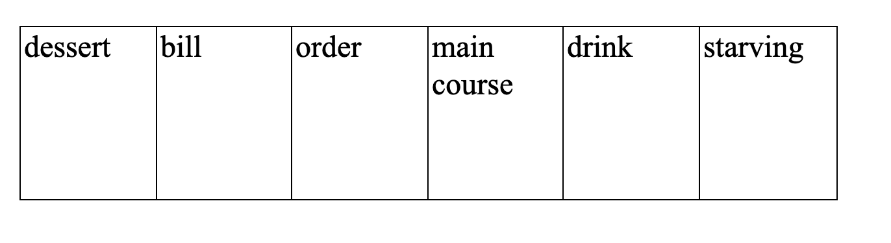

1. Are you ready to ... ,sir?
2. Shall we order now. I'm ... .
3. Could I have the please?

**5.Put the words in the correct order.**

1) Food, I, spicy, fried, eat and, can't.

2) Was, but, terrible, the food, and, burnt.

3) You, have, Chinese, eaten, ever, food.

4) Curry, order, please, me, a chicken.

**IV. Complete the dialogues.**

l) Can I help

2) Would you like

3) Do you want

4) Would you like

1. A.:___ to see the dessert menu, madam?

В.: No, thank you. I'm full.

A.: Would you like some tea or coffee?

В.; I___some coffee please.

**2)** A.:___you?

В.: yes. I'd like a cheeseburger and some chips.

A.:___anything to drink?

В.: Ice water, please.

**V. Translate into English your answers to a**

**receptionist.**

Good afternoon. I'm Andrew, and I'm your waiter for today. Would you like a drink while you're looking at the menu?

* Так, будь ласка, два томатних соку.
* Certainly. I’ll bring them right now.
* Have you decided, sir? May I take your order?
* Будь ласка, можна мені салат із свіжих огірків і зелений чай з тістечком. Який десерт мені замовити?
* I'd recommend you the fruit salad.

-Добре, дякую.

**VI. Заключна частина.**

Домашнє завдання. Підготувати усну розповідь про одну із традиційних українських страв.

**LESSON 7**

**ТЕМА: АМЕРИКАНСЬКА ЇЖА**

**Training**: активізувати лексику з теми;

**Practical**: проконтролювати навички читання, засвоєння лексико - граматичних структур;

**Developing**: розвивати пізнавальний інтерес до звичаїв інших народів;

**Educational**: виховувати повагу до культурних звичаїв та традицій ;

**Equipment**: підручник, вірші, приказки про їжу.

**Хід уроку**

**І. Introduction**

Т.: Tell me, please, do you know much about American meals and food? There is a saying "Tell me who your friend is and I'll tell you who you are". If I paraphrase, it will sound as "Tell me what you eat and I'll tell you who you are" When we say pizza, we think of Italy; sushi - Japan, champagne – France; borsch. varenyky - Ukraine. Name, please, a special American food. ( Pupil'spossible answers are coca - cola, hamburgers, hot - dog). Today we will learn more about it and find that hamburgers are an American product.

**II. Основна частина уроку.**

Т.: The topic of our lesson is "American Meals and Food. What is it?" Let's read the text about it and find out unknown facts.

**AMERICAN FOOD**

What is American food? The answer is that it is partly Italian, partly British, partly German, partly Mexican, partly Chinese... When people from other countries came to live in the USA, they brought different cooking traditions. Some of them opened restaurants. Today Americans enjoy food from all over the world.

Over the years some foreign dishes changed a little. For example, their favorite doughnuts were originally from Holland. In 1847. a young American boy told his mother that her doughnuts were never cooked in the middle. He cut out the canters and his mother cooked the rings — and they were very tasty!

Americans eat a lot. and when they go to a restaurant, they do not expect to be hungry afterwards. Most restaurants will put a lot of food on your plate — sometimes it can be too much. But if you can't finish it all, don't worry: they will give you a "doggy bag" and you can take it home.

You can also come across the expression "brunch" which is a combination of breakfast and lunch usually eaten late on a Sunday morning when people can sleep late and yet it is too early to eat lunch.

**2. Тренування учнів у діалогічному мовленні**

**1. In threes act out the conversation.**

**Children:** We are hungry, granny. Is dinner ready?

**Granny:** Just a moment. Wash your hands and help me to lay the table, please.

**Children:** We are ready.

**Granny:** Put the bread basket and butter-dish on the table, Kate.

Nick, are there tablespoons, folks and knives on the table?

**Nick:** I am putting them on, granny.

**Kate:** And **I** am putting the salt and pepper shakers. Where is our mustard?

**Nick:** Here it is in the jar. And here is ketchup. I like ketchup on my cutlets.

**Granny:** Sit down, children. Nick, don't read while eating your soup.

**Kate:** And don't lick your spoon. Remember your table manners.

Pass the salt and the pepper, please. My soup isn't salty enough. But it's too hot for me.

**Nick:** Don't speak with your mouth full, remember your table manners! And don't put so much pepper and salt. You are making your soup too spicy. And stop slurping, please. Don't forget about your table manners.

**Kate:** Granny! Tell him to stop nagging at me!

**Granny:** Well, Nick... You mustn't eat too much spicy food, Kate.

**Kate: I** like it this way. It's tasty. I don't like bitter or sour things.

**Granny:** Cocoa or tea, Nick?

**Nick:** Cocoa for me. And no sugar, please. I like it bitter

**Kate**: Cocoa is never too bitter. It's sweet. And I like it when it tastes sweet, not bitter.

**Nick:** You have a sweet tooth. Thank you, granny, everything is very tasty.

**Granny: I** am glad you like it.

**2. In pairs read the sentences and write them into two columns.**

1. Я не люблю котлет.

2. Моя сестра звичайно не снідає о сьомій годині.

3. Візьми шматок хліба.

4. Зателефонуй мені через 15 хвилин, я зараз готую їжу.

5. Я вечеряв, коли увійшов мій друг.

**Reading:**

Try to make these things in pairs. One of you will tell about what you need and another will tell us about what you don*t need. Use some and any.

Ex: borsch (малюнки капусти, моркви, сливи, картоплі, меду, буряка).

A: We need some cabbages, some carrots, some potatoes, some bubs.

B: We don't need any plums or any honey.

1. Vegetable soup (малюнки картоплі, суниці, гороху, солі, моркви, молока).
2. A lemon cake (малюнки риби, борошна, масла, цукру, кефіру, буряка).
3. Varenyky (малюнки сиру, яєць, цукру, кефіру, винограду).
4. Strawberry jam (малюнки гороху, цукру, суниць, молока).
5. A cup of tea (малюнки чайника з водою, вишень, пакетиків чаю, цукру, яєць).
6. A banana milkshake (малюнки помідорів, солі, бананів, морозива та вершків, молока).
7. **Заключна частина**

Homework:

1. Write down the new words into your vocabulary and learn them.
2. Write down your daily menu.

When we want our food today.

Do you want chips?

Do you want rice?

Do you want cutlets?

I think they're nice.

Do you want spaghetti?

Do you want beans?

Do you want peas?

Do you want pizza?

Say please, yes please.

2) I’ll have a proper cup of coffee In a proper coffee cup.

3) Peter Piper picked a peck of pickled peppers; A peck of pickled peppers Peter Piper picked; If Peter Piper picked a peck of pickled peppers, Where's the peck of pickled peppers Peter Piper picked?

3) After dinner sleep a while, After supper walk a mile.

4) Live not to eat, but eat to live.

5) Eat at pleasure, drink **with** measure.

6) Read the poem:

Mother bakes such lovely pies,

They smell and taste so fine

That when my daddy looks at them,

He always says, "My. my!"

The pies we make are pretty too,

Sally and me and Bud.

They look so fine, and nice to eat.

But they are made of mud!

**III. Заключна частина уроку.** **Homework.**

Review the topical words and expressions for our theme "Food" because at the next lesson you'll do the test.

**LESSON 8**

**ТЕМА. ТЕМАТИЧНА АТЕСТАЦІЯ. TEST ON THE TOPIC "MEALS"**

**Practical**: перевірити рівень навченості учнів по темі;

**Developing**: розвивати логічне мислення;

**Training**: сприяти вихованню зацікавленості у вивченні англійської мови;

**Equipment**: чотирирівнева контрольна роботи з додатковим завданням (у двох варіантах);

**Туре**: урок перевірки знань, умінь і навичок.

**Хід уроку**

**І. Introduction**

We are having a test today. You'll be able to show the level of your speech and language competence on the topic of communication "Meals". Our test consists of four levels. You'll get two points for the first and second levels each; five - for the third and three - for the fourth. Try to answer the bonus question and get additional points.

**I variant**

**I. Translate into Ukrainian.**

1. to pay bill
2. to have a good meal
3. to lay the table
4. The children usually have lunch at the school canteen.
5. She never puts sugar into the tea.
6. Would you like a glass of juice? - No, thank you.

**II. Translate into English**

Я люблю готувати.

Вона звичайно снідає о восьмій.

Що ти зараз робиш? - Я обідаю.

Коли ти будеш обідати завтра? - Не знаю.

Ти любиш пироги з сиром?

**III. Underline the proper adjectives in bold.**

1. The food was delicious/horrible. All the dishes that we tasted
2. Were well - cooked and freshly made.
3. The service was extremely fast/slow. We waited for half an hour before a waiter appeared.
4. The staff were very helpful and polite/rude. Our waiter took her time to explain the menu to us in detail.

**IV. Put the words in the Correct order.**

1. Curry, order, please, me, a chicken.
2. Eating, meat, usually, meat, avoid, any, products.
3. To drink, like, you, would, anything?

**VII. Bonus question.**

Give the recipe of your favourite Ukrainian dish.

**II variant**

1. **Translate into Ukrainian**
2. to be hungry
3. to clear the table
4. to order soup with vegetables
5. He said he was as hungry as a hunter

5. Would you like juice or water after dinner? I prefer strong tea with milk.

**II. Translate into English.**

1. Я не люблю котлети й кашу.
2. Моя подруга ніколи не обідає в ресторані.
3. Ви завжди п'єте каву? - Не завжди. Інколи я п'ю чай.
4. What do you usually prepare for breakfast?

**III. Underline the proper adjectives in bold.**

1. The menu was boring / varied and had a great selection of salads, pastas and meat dishes.
2. The food was rather expensive / cheap. We had to pay almost 600 hrivnias for two people.
3. The restaurant was quite quiet / noisy. The music was so loud that 1 couldn't hear what my wife was saying.

**IV. Put the words in the Correct order.**

1. Food, 1, spicy, fried, eat, and. **can't.**
2. Was, but, terrible, the food, and, burnt.
3. You, have, Chinese, eaten, ever, food?

**V. Bonus question.**

Give the recipe of your favorite American dish.

Summarizing. During the lesson you had a chance to show the level of your communicative competence progress. You can be sure now that you know what to say, what to do if you invite guests from another country; and how to treat them to Ukrainian dishes. Also, you'll be able to order meals in a cafe in England.

**ВИСНОВКИ**

Даний посібник може використовуватись вчителем під час вивчення теми ”Харчування” у шостому класі. Без сумнівів, проблема повернення дітей до шкільних їдалень з території супермаркетів є вкрай важливою. Тому в час реформи харчування в школах є доцільним обговоренням даної проблеми на уроках англійської мови. Зміна ідей у харчуванні є ключовим аспектом у житті дітей, адже глобальна реформа охопила меню їдалень, а також законодавчу зміну норм харчування. Виховувати смаки у дітей і свідоме ставлення до власного здоров'я є основним завданням вчителя. Матеріали з даної теми знайшли своє висвітлення в матеріалах брошури “Навчаючись виховуємо”.

**СПИСОК ВИКОРИСТАНИХ ДЖЕРЕЛ**

1. Vavilova M. G. Let’s read faster. Київ. Вища школа, 2016.

2. Енциклопедія для підлітків. Н.Л. Вадченко, Н.В.Хаткіна. Донецьк: Сталкер, 2010. С. 99-102.

3. English through Communication. Київ.”Освіта” 2017. C.47-49.

4. Коганов А.В. Сучасна англійська мова. Київ.”А.С.К.’’ , 2014. С. 39-42.

5. НіколенкоТ.Г, Кошманова І.І. Англійська мова для дітей. Рольф. Москва, 2013. С. 89-92.

6. Англо-український словник у малюнках. Чернігів. Країна мрій, 2014. C.37-43.

7. Гужва Т.Англійські розмовні теми. Київ.Танде, 2018. С.39-41.

8. Барановська Т.В. Граматика англійської мови. Збірник вправ. Київ, 2013. С.15.

9. Книга Здорове харчування. 95 карток для вивчення англійської мови. Видавництво English Student. Серія книг. English Student Flashcards, Мова. Англійська, 2020

10. Premium B1 level 1 Coursebook. Pearson. Longman, 2018. С.119-125