Grade 9
Theme: Mass Media
Objectives: to practice students in using active vocabulary;
to develop listening, writing, reading and speaking skills;
to develop cooperative, communicative and digital skills;
to integrate web 2.0 tools in our learning process;
to motivate students to study during life.
Results: to improve digital and technology-based competences.
Equipment: PC, good Internet connection.
PLAN:
- What types of Media do you know?

Word Art 2 - Edit – WordArt.com

- Divide the mass media into groups.
Broadcasting:
Printed:
Digital:
- Explain the meaning:
- Match:
Television | 1. a paper printed and sold usually daily or weekly with large pages, serious news, etc.;
Newspaper | 2. the process of sending and receiving messages through the air; broadcasting programmes for people to listen to;
The Internet | 3. a way to communicate with your partner who might be a thousand miles away using the computer (e-mails);
Radio | 4. broadcasting programmes (the news, plays, advertisements, shows, etc.) for people to watch on their television sets.

- Match the words with their meanings:
gossip a headline a paparazzi tabloids an editor
- News about famous people which may or may not true.
- A title of newspaper’s article.
- A person in newspaper who decided what stories to publish.
- A photographer who takes photos to sell them.
- A newspaper with lots of photos of celebrities.

- Solve the crossword
https://crosswordlabs.com/embed/media-801

- Practice Vocabulary
https://wordwall.net/ru/resource/11119671
https://wordwall.net/ru/resource/11218909
https://www.liveworksheets.com/vv1416440jo
https://www.youtube.com/watch?v=0ZkWtiHJ-6s
https://listenaminute.com/m/media.mp3
https://create.kahoot.it/details/05fa192c-0cda-4e2c-810e-a8010216a24e
- Time to relax.
https://www.youtube.com/watch?v=pbD7Dcmlmws

- Listen to the text and unscramble the words:
Skype allows you to communicate by voice, messaging and video for free. The company was set up by Niklas Zennstrom and Janus Friis. They met in 1) markenD where they worked for the same company. They founded Skype in 2003. Very soon it became the global leader in online voice 2) mmutioncocain. In 2005, the 3) nycopam called E-bay bought Skype. By 2008, it had over 300 million registered users. In 2011, Skype was sold again. This time 4) softrociM purchased it. So how does Skype make money? Simple! By selling add-on features that people want to pay for. This include special 5) tonerisgn and voice-mail subscriptions.
Answers: 1) Denmark 2) communication 3)company 4)Microsoft 5) ringtones
True or False
- Skype was founded in 2005.
- You can call someone via Skype for some money.
- The company was set up by brothers.
- By 2008, they had more than 300 million users.
- Apple bought the company in 2011.
Answer the questions:
- When was Skype founded?
- Where was Skype founded?
- Who founded Skype?
- What company bought Skype in 2011?
- How often was Skype sold?
- Listen to and answer the questions:
https://listenaminute.com/m/media.html

- Who bring us the news?
- Is the job of journalist has many risks?
- What do the media show us?
- Is it dangerous to bring news from war?
- How would we get information about the world?
- Solve the crossword
https://crosswordlabs.com/embed/news-624
- Listen to the and complete:
Where would we be without the 1)___ ? How would we get information about the world?2)_________ us are interested in the news. We all 3)____to know what’s happening around the world. We switch the TV on just to watch the news. It 4)________though every train passenger has a newspaper. The journalists who bring us the news do a very important 5)__. Many risk their lives to bring us the news from the world’s 6)____. Unfortunately, many 7)____ are killed while they are covering a war. The media make us feel we are part of the world. We become experts on other countries and on the big news stories. The media also bring us many 8)___images, such as a man walking on the 9) __. 10)___, the media show us history as it happens.
- Read and match
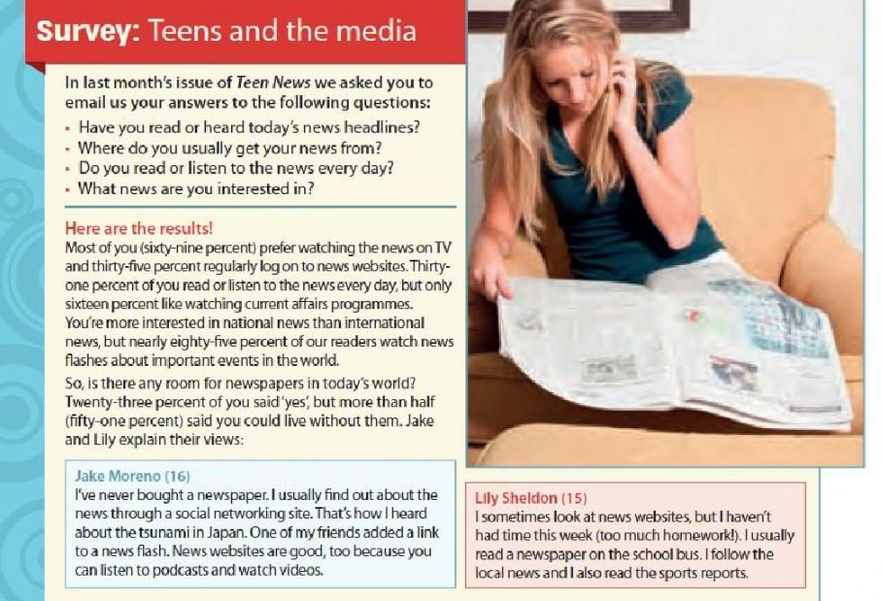
85% read and listen to news every day;
31% watch news about important news in the world;
35% could live without newspapers;
51% regularly log on news websites;
16% prefer watching news on TV;
69% like watching current affairs programmes.
- Play in Kahoot.
https://create.kahoot.it/details/05fa192c-0cda-4e2c-810e-a8010216a24e

- Homework: create a crossword using the Crossword Lab

