Горішньоплавнівська ЗОШ І-ІІІ ступенів №6
Учитель англійської мови: Алєксєєва Світлана Леонідівна
Form 5
Theme: Clothes We Wear
Aims and purposes of the lesson:
• to activate the lexical material on the topic and familiarize with new words,
• to develop listening, reading, speaking and writing skills,
• practice in using of new words in oral speech and in writing,
• to develop the skills of dialogical speech,

• to widen students’ knowledge to the topic,
• to deepen the knowledge of students about clothes,
• to develop skills of social competence,
• to develop skills of independent work
Equipment: books, cards, additional material
Procedure:
I. Greeting (Slide 1)
Teacher: Good morning, dear children. I am glad to see you. How are you? Hope, you are OK, all of you are well, ready to work and positive, because the topic of our distance lesson is really cool. We are going to learn everything about things which are comfortable, colourful, warm or light for summer time. We can put them on our legs, hands, feet, heads, necks and bodies. Can you guess the name our topic?
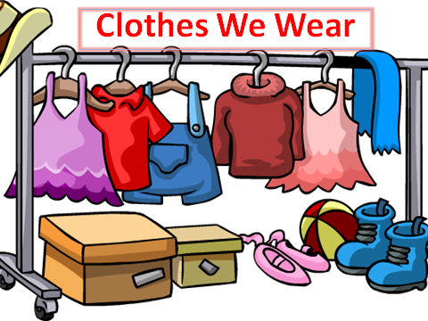
II. Warming up (Slide 2)
2.1 Teacher: Watch the video and repeat.
https://www.youtube.com/watch?v=sQbSfZu26B8
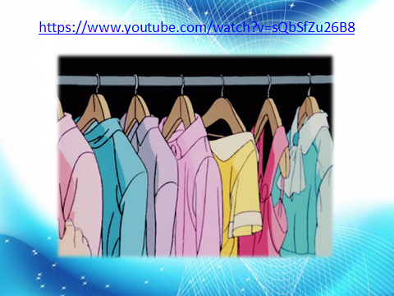
2.2. Speaking skills (Slide 3)
Teacher: Answer the questions.
- What are you wearing today?
- Do you wear any special clothes for your distance learning?
- Are your clothes comfortable and warm enough?
- Do you put on your school uniforms for the distance lessons?
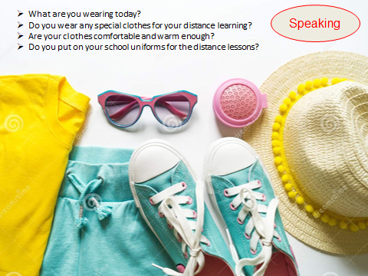
III. Main Part
- Vocabulary box (Slide 4)
Teacher: Read the words.
A sweater, a T-shirt, a blouse, a coat, a scarf, a suit, trainers, boots, gloves, a hat, socks, a dress, shorts, jeans, a pair of jeans, mom jeans, skinny jeans, baggy jeans, hoody/hoodie, a sweatshirt, oversize, trousers, a pair of trousers, a jacket, a uniform, a scarf, tights.
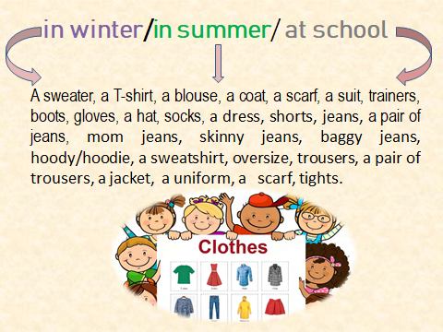
- Speaking (Slide 5)
Teacher: What clothes do we usually wear in winter/in summer/at school/on a picnic?
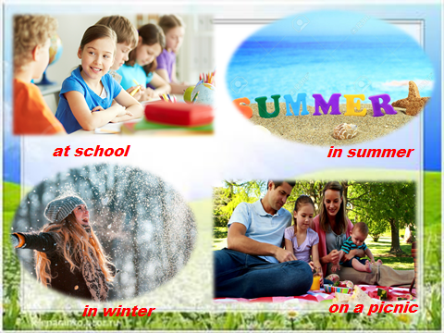

- Lexical drill ( Slide 6)
Teacher: When we buy or put on clothes, we always choose them according to the colours, sizes or comfort. The next task is to help a girl with her clothes. Correct the expressions.
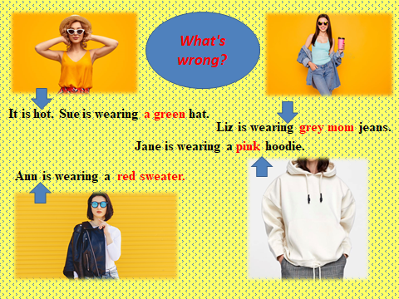
- Reading (Slide 7)
Teacher: Let’s read.
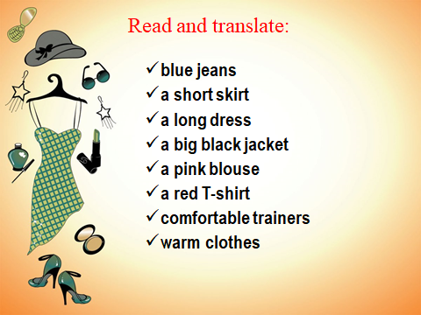
- Speaking
Teacher: Read the sentences. Agree or disagree it!
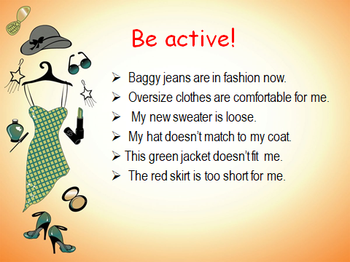

- Writing skills (Slide 7) (Працюють асинхронно)
Teacher: Now it’s time to test yourselves! Do the task from Google Classroom.
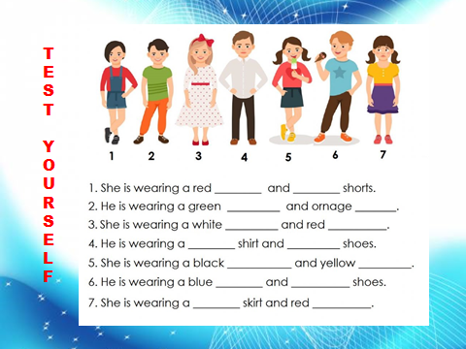
- Sum up. Homework
Teacher: Children, was the lesson interesting for you?
What task was the easiest one?
What task was boring?
You homework consists of two parts. The 1st task is to answer the question. Complete 5-7 sentences.
The 2nd part is to do the exercise from your textbook.
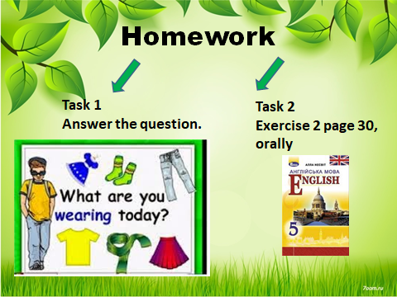
Of course, there are some extra exercises for you to practice your vocabulary and grammar! Enjoy!
- Extra activities (Додаткові завдання для дітей на закріплення та активізацію матеріалу до теми)
