Розробка уроку з англійської мови

10 клас

Тема: The United Kingdom of Great Britain and Northern Ireland. London.

Мета: систематизувати й узагальнити знання учнів по темі «The UK», активізувати вживання тематичної лексики та вдосконалити монологічне та діалогічне мовлення, розвивати навички аудіювання та комунікативні вміння, розширювати світогляд учнів.

Обладнання: комп’ютер, мультимедійний проектор, карта.

Procedure

**I. Introduction.**

**T: Good morning, children. I am glad to see you. Let’s start our lesson. Today we are going to revise everything you have learned about the UK. I wouldn’t give you any marks. It is winter now, so I think, that snowflakes for your correct answers will be better than marks. Look, you can see fir-trees on your desks. Today we’ll work in groups. At the end of the lesson we’ll decorate our fir-trees with snowflakes. We’ll see whose fir-tree is decorated better. So, this team will be the winner.**

**II. Warming-up**

**T: But firstly let’s have a talk with you. Winter is coming. It brings a lot of holidays not only for the Ukrainians. The British have a lot of traditions connected with winter holidays. What are these traditions?**

**Possible answers:**

**S1 : For many British families Christmas is the most important holiday of the year.**

**S2: They celebrate Christmas on the 25th of December.**

**S3: The most important and pleasant tradition of Christmas is the giving of presents to your friends and relatives.**

**S3: People wrap up their gifts and leave them at the bottom of Christmas tree to be found on Christmas morning.**

**S4: The first of January is New Year’s Day, but mostly it is celebrated in Scotland. Friends usually come on this day.**

**S5: In England New Year’s Day is not so popular. In London people go to the Trafalgar Square. In this square they see a great tree brightly decorated with little lamps.**

**S6: They also wish a Happy New Year to each other.**

***III. Main part.***

***1.Introducing the theme.***

***T: Children , today at our lesson we are to review everything from the topic «The UK».Listen to the speaker and repeat after him.***

***-the United Kingdom of Great Britain and Northern Ireland***

***-England***

***-Scotland***

***-Wales***

***-the Thames***

***-the Severn***

***-Edinburgh***

***-Cardiff***

***-Belfast***

***-Trafalgar Square***

***-Westminster Abbey***

***-Buckingham Palace***

***-Tower Bridge.***

***2.Work with the map.***

***T: Using the map try to continue sentences on the slides:***

***a) Great Britain consists of…***

***b) The UK consists of…***

***c) Great Britain is washed…***

***d) Ben Nevis is...***

***e) The surface of Scotland and Wales is…***

***f) The Severn is…***

***g) London stands on the river…***

***h) The biggest cities of Great Britain are…***

***i) Wales is famous for…***

***j) Perhaps, we can see a monster…***

***.*** 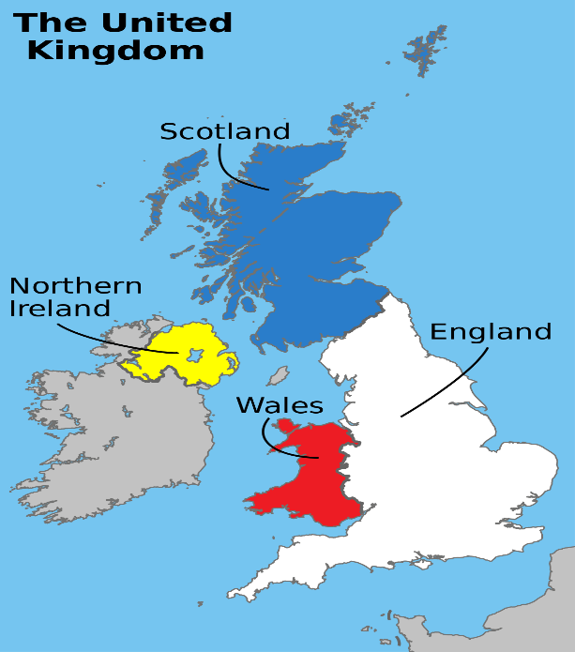

***3.Reading.***

**T:Look through the text and be ready to find out if the facts are true or false.**

The climate of Great Britain is mild and damp due to the influence of Gulf Stream,the warm ocean current.The climate varies depending on the time of the year and the area.

England ’s driest months are July and August with very little rainfall.Temperatures are warm with an average of around 25˚C .During the winter months,the rainfall increases amazingly.Almost every day in January and February sees rain or cold winds..Temperatures fall to a little above 0˚C and the sun is rarely seen.Wales located to the west of the island is a mountanous part.Clouds from the Atlantic causes large amount of rainfalls in this area.

**Find out if the facts are true or false.**

**1)The climate of Great Britain is mild and damp.(T)**

**2)The Gulf Stream influences the climate.(T)**

**3)England’s driest months are January and February.(F)**

**4)** ***.Clouds from the Atlantic causea large amount of rainfalls in this area.(T)***

**4.Listening to the text**

**T: Now listen to the text, try to understand everything**

London

London, one of the world’s biggest cities, situated on the river Thames, is the capital of the United Kingdom of Great Britain and Northern Ireland. London is a great industrial and cultural centre with the population of more than eight million people. London consists of 4 main districts. They are the City, Westminster, the West End and the East End. The City is small in area, but it is the business centre of London. Many banks and offices are situated there. Westminster is the most important part of the capital. The Houses of Parliament are there. To the West of Westminster is the West End. Here we find most of the big shops, hotels, museums, art galleries, theatres and concert halls. To the east of Westminster is the East End, an industrial district of the capital. There are no parks or gardens in the East End and you cannot see many fine houses there. Most of the plants and factories are situated there.

T: Translate from Ukrainian into English.(sentences are on the slides with differernt variants of answer.)

1) Лондон розташований на річці Темза.

2) Лондон- це великий індустріальний і культурний центр.

3) Лондон складається з чотирьох районів.

4) Сіті- діловий центр Лондонa.

5)Вестмінстер-адміністративний центр Лондона.

6)У Вест-Енді ми бачимо великі магазини, готелі, музеї, галереї мистецтв, театри та концертні зали.

7)Іст-Енд є промисловим районом столиці.

8)Більшість заводів і фабрик розташованo там.

***5. Group Work;***

T: Children: let’s imagine that we are in London and we’ll visit the Br1t1sh

Agency of Travelling.So, meet the guides and give them questions.

G1: Hello, friends! Really, London is a great city. There are many sights in

London. We want to tell you about them.

S1: Tell us about the Tower Bridge and the Tower.

G1: The Tower is one of the oldest historical places of London. In history the Tower has been best known as a prison for enemies of the King. Реор1е say, ghosts of men and women who died in the Tower still walk here at night There are many buildings here, but the most important is the white TOWER.It is the oldest. Its walls are 30 metres high. There is a jewel House and the collection of arms in it.

S2: What is Westminster?

G2: Westminster is the political centre of the United Kingdom — the home of the British Parliament. You can visit the Houses of Parliament and London’s famous clock Tower Big Ben. Next to the Parliament there is Westminster Abbey All the English monarchs have been crowned there for 600 years. 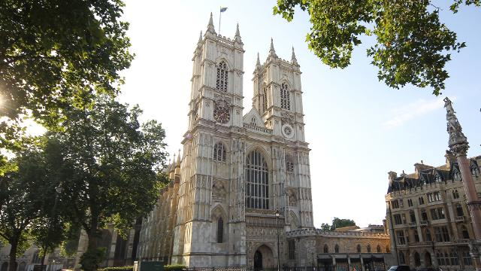

Queen Elizabeth I, scientists Newton, Darvin; writers Burns, Dickens, Shakespeare and many famous people are buried here.

S3: Where do people like to spend their free time in London?

G3: Trafalgar Square is the heart London. It is the place where tourists

usually start their trip. In the centre of Trafalgar Square there is the column

with the statue of Lord Nelson. The fountains and friendly pigeons make Trafalgar Square popular for Londoners and tourists. It is the place for political demonstrations and public meetings. At Christmas singers gather here round a Christmas tree which is sent to Britain from Norway every year.

S4: What is the ofﬁcial home of the Queen?

G4: Buckingham Palace is the most famous British royal home. When the Queen is at home the national ﬂag on the top of the palace is ﬂying. A very popular British tradition is connected with Buckingham Palace. It is changing of the guard. The ceremony is very colourful. There is always music during it. Many tourists come to watch the changing of the guard. There are 600 rooms on 3 floors, a swimming pool in the palace.

S5: I know that during the great ﬁre in London one of the churches was

completely ruined. What church was it?

G5: St. Paul‘s Cathedral is one of the most famous places in the capital. It was designed by sir Christopher Wren. It took him 35 years to ﬁnish St. Paul‘s cathedral.

He built more than 50 churches after the fire, but this is his masterpiece. Among the famous people buried in St. Paul‘s Cathedral are Lord Nelson, Wellington, sir Cristopher Wren himself. We may say that St. Paul’s is a real memorial to the great master. 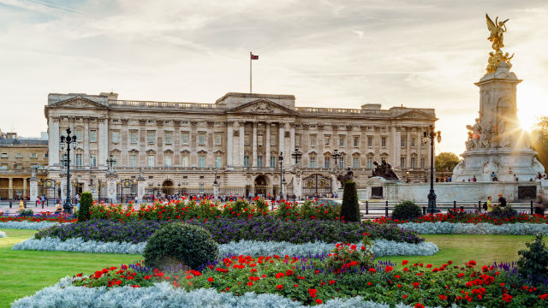

G6: So, we invite you to visit London — the capital of our country. Welcome to London!

**6. The game: “Try to guess”.**

T: Now, try to guess what sight of London I‘m speaking about. (after the correct answer the teacher shows the picture)

1) This circus is the heart of London‘s West End (Piccadilly Circus)

2) This palace was built in the 18th century. Now it is the residence of the royal family. It has 600 rooms and 3 miles of a red carpet. (Buckingham Palace)

3) This church is more than 900 years old. Nearly all kings and queens were crowned there. (Westminster Abbey)

4) Monument to one of the world’s greatest writers. (W. Shakespeare)

**7. Reading quotation.**

Teacher draws pupils’ attention to the quotation about London: “When a man is tired of London, he is tired of life...”

T: Try to explain these words.

S1 : It’s impossible to be tired of London.

S2: It is a great cultural centre.

Sз: Everyone can find something interesting for himself.

S4: Nobody can be indifferent to the history and architecture of this city.

**8. T:At the end of our lesson let’s organize a game “The smartest”.**

You will have 3 rounds. You discuss questions in your group if you need. If YOU know the correct variant, answer it. 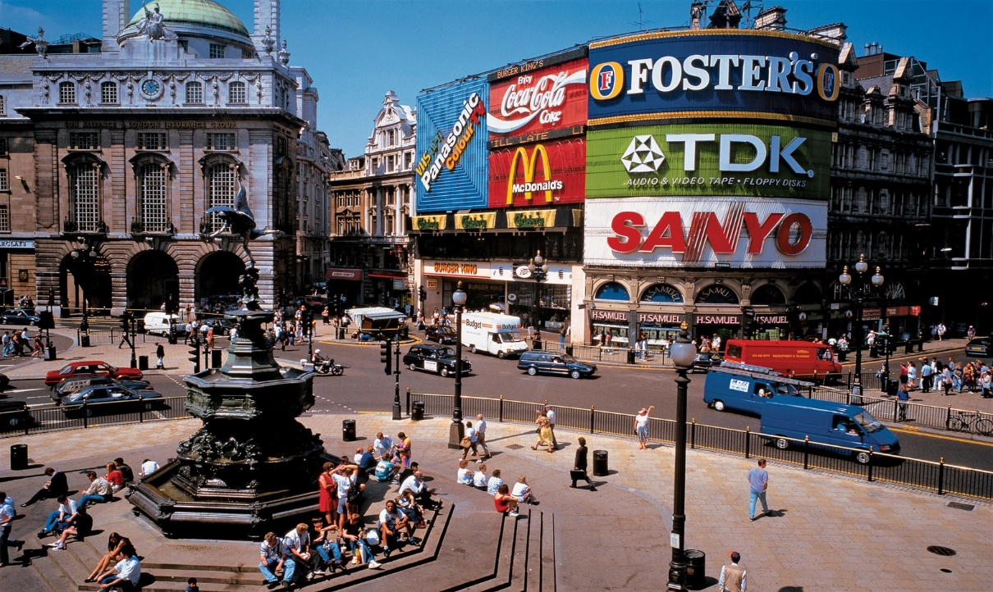

**I Round**

**1. English is not spoken in**

a) the USA

b) Australia

c) New Zealand

d) Germany

**2. Which of these rivers is not in Great Britain?**

a) the Severn

b) the Colorado

с) the Thames

d) the Tweed

**3.Which of these countries is not in Great Britain?**

a) England

b) Wales

c) Northern Ireland

d) Scotland

**4.Scotland lies to the…of England**

a) north

b) south

c) west

d) east

**5.Famous scientists, kings, writers, poets are buried in**

a) the National Gallery

b) Trafalgar Square

c)Westminster Abbey

d) the Tower

**6. Who wrote the book, from which these words are: “Whale ,whale .have you eaten a man?»**

a) R. Kipling

b) W. Shakespeare

c) O. Henry

d)J. London

**II Round**

**T. Some questions from literature**

1)What’s the author of Robinson Crusoe? (D.Defoe)

2)What town was Shakespeare born in?(Stratford on Avon)

3)Who said: «To be or not to be ?»(Hamlet)

4) Who said: « I’ll never call you aunt again as long as I live.»(J. Eyre)

5) What was Conan Doyle? (A doctor)

**III Round**

T: I ‘d like you to speak on two topics: «British weather» and « National stereotypes of the British» l give you a minute for preparation.(Pupils represent their project works)

a) We know that Great Britain is called “Foggy Albion.“ It may come from Latin word “albus”. meaning “white". We see fog in winter and in autumn very often. When two Englishmen meet they often talk about the weather. You may hear very often: “It rains all the time. It is very damp. There is a

terrible fog in London“.

“Other countries have climate, in England we have weather". It will be very interesting, for you to know that Britain has more than 200 rainy days a year. The English say that they have three variants of weather: when it rains in the morning, when it rains in the afternoon, and when it rains all day long. Sometimes the rain is very heavy and people say: “It‘s raining cats

and dogs”. The climate in Great Britain is generally mild. It is never very hot in summer and never very cold in winter.

b) British people don’t allow the straight forward expressions of what

they think and feel. A conversation in English is full of hints, halftones

and half-statements.

British people don’t particularly like to interfere in other people‘s affairs. They have а cult of privacy. In a conversation they mostly avoid direct questions and strong dogmatic ones .

The British are extremely reserved people. They are industrious,

polite, tradition—loving, honest, nationalistic. The British is also a nation

of animal-lovers. They have a speciﬁc sense of humour. The typical feature of the English is their love for games. They play

football and cricket. But being childish at their games they are very serious in business. Scotsmen are the only nation in Europe where men prefer to wear

skirts not trousers. Men put on skirts, or kilts as they call them, not only to take part in festivals or carnivals. Scottish people like to dance very much. They are very clever and simple. They have a natural sense of humour. Scottish people work hard. They don’t like to spend money on themselves. But they are very generous with their friends and relatives.

T:I see, two teams have nice results. You worked well. Thank you.

**IV. Home assignment**.

T: You are to read the text at page 41 “English Children” and be ready to retell it and write about the rules at your school.

**V. Summing— up.**

T: Our lesson is coming to its end. I’d like to say that you worked well at the lesson. So, you are hard-working children. Let’s decorate our ﬁr trees with snowﬂakes. So, we see that both teams worked hard, both of them are the winners. Soon British people will celebrate one of the best holidays — Christmas. Christmas traditions are very rich. People always prepare presents. We can’t change this

tradition and we want to give the members of our commission greeting cards and wish “Merry Christmas and the Happy New Year!” Now let’s sing the song "Jingle Bells."