[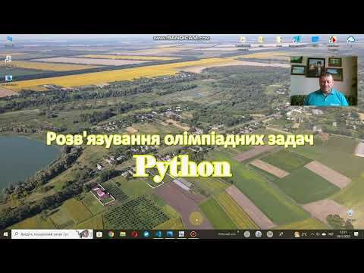](https://www.youtube.com/embed/videoseries?list=PLZFiZxjQN52LSwv6AlbIo5IBmJiz8SHBV)

<https://www.youtube.com/playlist?list=PLZFiZxjQN52LSwv6AlbIo5IBmJiz8SHBV>